d

TOne CDR Technical Document

Contents

Document Purpose 2

Module Overview 3

Module Components 3

Visual Studio Projects 3

Module Dependencies 3

Required Databases 3

CDR Import, Billing, Pricing, and Statistics Processes 5

Import CDR Process 5

Store CDRs in DB Process 6

Raw CDRs Process 6

Billing CDRs Process 6

Store Main CDRs in DB Process 7

Store Invalid CDRs in DB Process 7

# Document Purpose

The purpose of this document is to discuss the CDR module and related processes. This includes:

* CDR Import, Pricing, and Statistic Calculation
* Repricing

# Module Overview

The CDR module is responsible of importing CDRs into TOne, manipulating them, doing analysis on top of them, and other related business functionalities

## Module Components

The following table shows the different components of the CDR Module:

|  |  |
| --- | --- |
| Component Name | Type |
| Import CDRs Process | Workflow |
| Raw CDRs Process | Workflow |
| Billing CDRs Process | Workflow |
| Store CDRs in DB Process | Workflow |
| Store Main CDRs in DB Process | Workflow |
| Store Invalid CDRs in DB Process | Workflow |
| Generate Statistics Process | Workflow |
| Repricing Process | Workflow |
| Store Statistics in DB Process | Workflow |

## Visual Studio Projects

The following table shows the visual studio projects of the Routing Module:

|  |  |
| --- | --- |
| VS Project Name | Notes |
| TOne.CDR.Entities |  |
| TOne.CDR.Data |  |
| TOne.CDR.Data.SQL |  |
| TOne.CDR.Business |  |
| TOne.CDRProcess | CDR Workflows |
| TOne.CDRProcess.Activities | CDR Workflow Activities |
| TOne.CDRProcess.Arguments | CDR Workflow In/Out Arguments |

These projects are located in TOneV2 solution under “C:\TFS\TOneV2\Code\TOneV2”

## Module Dependencies

The following table shows the dependencies of the Routing Module:

|  |  |
| --- | --- |
| Dependency Name | Location |
| TOne Main Module & Business Entity | TOneV2 solution |
| Vanrise.Common & Vanrise.Caching | Vanrise Framework solution |
| Vanrise.Data & Vanrise.Data.SQL | Vanrise Framework solution |
| Vanrise.Queueing | Vanrise.BusinessProcess Framework solution |
| Vanrise.BusinessProcess, Vanrise.BusinessProcess.Entities, & Vanrise.BusinessProcess.WFActivities | Vanrise.BusinessProcess Framework solution |
| TABS and switch related dlls | Old Solution |

## Required Databases

|  |
| --- |
| Database Connection String Name |
| MainDBConnString |
| TransactionDBConnString |
| LogDBConnString |
| QueueItemDBConnString |

# CDR Import, Billing, Pricing, and Statistics Processes

The following diagram show all Processes, Queues, and database tables involved in the Import CDRs, Billing, Pricing, and Statistics generation:

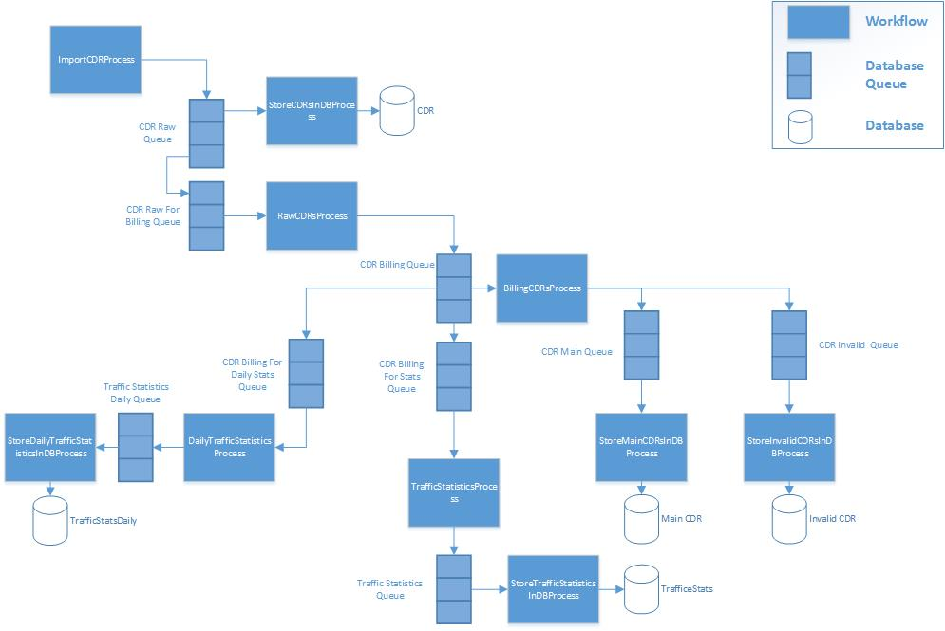

The following sections describes each process and its related entities:

## Import CDR Process

|  |  |
| --- | --- |
| ImportCDRProcess | |
| Job Summary | Import new CDRs from a Switch and submit them to database Queues |
| Trigger | Time Schedule |
| Input | * SwitchID: the database Id of the switch from which to import CDRs |
| Output | * CDRRawQueue: database Queue * CDRRawForBillingQueue: database queue having CDRRawQueue as source queue |
| Parallel Restriction |  |
| Tables Affected | None |
| Sequence of Execution | 1. Start retrieving batches of CDRs from the switch 2. Enqueue the CDRs batch to the output Queue (CDRRawQueue) |

## Store CDRs in DB Process

|  |  |
| --- | --- |
| StoreCDRsInDBProcess | |
| Job Summary | Get imported CDRs from the Queue and store them to the database |
| Trigger | Whenever the input database queue has items |
| Input | * SwitchID: the database Id of the switch from which the CDRs are imported * CDRRawQueue: database Queue |
| Output |  |
| Parallel Restriction |  |
| Tables Affected | * CDR |
| Sequence of Execution | 1. Start retrieving batches of CDRs from the CDRRawQueue 2. Store each batch of CDRs in the CDR table |

## Raw CDRs Process

|  |  |
| --- | --- |
| RawCDRsProcess | |
| Job Summary | Get imported CDRs from the Queue and generate Billing CDRs (without pricing) |
| Trigger | Whenever the input database queue has items |
| Input | * SwitchID: the database Id of the switch from which the CDRs are imported * CDRRawForBillingQueue: database Queue |
| Output | * CDRBillingQueue: database Queue * CDRBillingForStatisticQueue: database queue having CDRBillingQueue as source queue * CDRBillingForDailyStatisticQueue: database queue having CDRBillingQueue as source queue |
| Parallel Restriction |  |
| Tables Affected | None |
| Sequence of Execution | 1. Start retrieving batches of CDRs from the CDRRawForBillingQueue 2. Process CDRs by assigning Customer, Suppliers, and Zone properties 3. Enqueue the billing CDRs batch to the output Queue (CDRBillingQueue) |

## Billing CDRs Process

|  |  |
| --- | --- |
| BillingCDRsProcess | |
| Job Summary | Get billing CDRs from the Billing CDR Queue and apply pricing properties |
| Trigger | Whenever the input database queue has items |
| Input | * SwitchID: the database Id of the switch from which the CDRs are imported * CDRBillingQueue: database Queue |
| Output | * CDRMainQueue: database Queue * CDRInvalidQueue: database Queue |
| Parallel Restriction |  |
| Tables Affected | None |
| Sequence of Execution | 1. Start retrieving batches of Billing CDRs from the CDRBillingQueue 2. Generate pricing properties of type Main CDRs 3. Enqueue the billing CDRs of type Main to the CDRMainQueue 4. Enqueue the billing CDRs of type Invalid to the CDRInvalidQueue |

## Store Main CDRs in DB Process

|  |  |
| --- | --- |
| StoreMainCDRsInDBProcess | |
| Job Summary | Get main CDRs from the CDR Main Queue and stores them in the CDR Main tables |
| Trigger | Whenever the input database queue has items |
| Input | * SwitchID: the database Id of the switch from which the CDRs are imported * CDRMainQueue: database Queue |
| Output |  |
| Parallel Restriction |  |
| Tables Affected | * Billing_CDR_Main * Billing_CDR_Cost * Billing_CDR_Sale |
| Sequence of Execution | 1. Start retrieving batches of Main CDRs from the CDRMainQueue 2. Store each batch of CDRs in the main CDR tables (Billing_CDR_Main, Billing_CDR_Cost, Billing_CDR_Sale) |

## Store Invalid CDRs in DB Process

|  |  |
| --- | --- |
| StoreInvalidCDRsInDBProcess | |
| Job Summary | Get invalid CDRs from the CDR Invalid Queue and stores them in the CDR Invalid tables |
| Trigger | Whenever the input database queue has items |
| Input | * SwitchID: the database Id of the switch from which the CDRs are imported * CDRInvalidQueue: database Queue |
| Output |  |
| Parallel Restriction |  |
| Tables Affected | * Billing_CDR_Invalid |
| Sequence of Execution | 1. Start retrieving batches of Invalid CDRs from the CDRInvalidQueue 2. Store each batch of CDRs in the invalid CDR table (Billing_CDR_Invalid) |